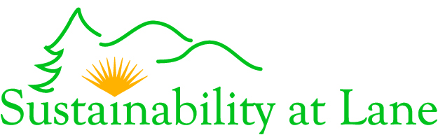
National Conference on Sustainability for Community Colleges
Lane Community College
April 16 & 17, 2008

KEYNOTE SPEAKER DVD ORDER FORM

First name*: Last Name*:

Organization:

Mailing Address*: City*: State*: ; Zip code*:

Phone number*:

*Required information

Fill in this information for Credit Card orders only:
______________________________________________________________________________
Type of Credit Card (Visa or Mastercard only):

Name as it appears on card:

Account number:

Exp. Date:

Credit card billing address (if different from address provided above):
Mailing address: City: State: Zip code:
_____________________________________________________________________________________________________________________

DVD | Quantity | Cost per DVD | Subtotal
Denis Hayes – Preparing for Life in a Climate Neutral World |  | $15
Dr. Rusty Stephens – Sustainability: Community Colleges at the Heart Center |  | $15
Both Denis Hayes and Dr. Rusty Stephens Keynote Addresses |  | $20
TOTAL

To pay with a check, please mail a check along with this completed order form to:

Sustainability Office
Lane Community College
4000 E. 30th Ave.
Eugene, OR 97405

To pay with a Visa or Mastercard, you may order DVDs in one of three ways:

- Call in an order: You may call 541-463-5594 to place an order by phone. Please have your Visa or Mastercard ready when you call.
- E-mail in an order: Save this form on your computer. Fill it out with credit card information and e-mail it as an attachment to sustainability@lanecc.edu.
- Mail in an order: Fill out this form with credit card information and mail it to the address shown above.

