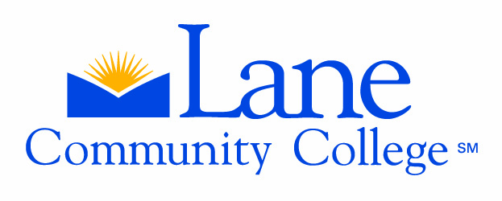
The Professional Technical Education Coordinating Committee provides guidance
and support to advisory committees, in partnership with the business community,
to promote a quality workforce.

PTECC
Advisory Committee Interview
December 13, 2005

INTERVIEW FITNESS TRAINING ADVISORY COMMITTEE:
Presented by Interim Division Chair – Roger Bates; Committee Chair – Marisa Hastie; Advisory Chair – Amy Freeman, and Sue Thompson.

1) Committee Accomplishments: Excellent
The committee started out fairly small. Marisa joined the department in June 2005, and Amy has been on the committee for 3 years. After the Fall Kickoff breakfast Marisa could see their committee needed to expand. They are a very passionate committee.

The committee was meeting twice a year, but now meets quarterly. They have grown to twenty members. The committee as been Increasing involvement in the community with other professional organizations, creating an opportunity to do more networking. The committee receives a lot of support from the community financially, as well as with networking and mentors. They develop and update a website and comprehensive list of contacts, as well as printed marketing materials. Sub-committees help work on goals set by the committee

The importance of Co-op is very evident. Leadership techniques are promoted, building confidence, conducting workshops, and improving writing skills. There is a lot of personal involvement. Students start out with goal sheets, and the staff continues to touch base with their progress while the students improve skills.

2) Committee Involvement in Planning and Design: Excellent
Strategies to keep the program state of the industry are a constant goal to keep up with fitness trends and changes. The committee reads journals and stays in touch with colleagues. They attend trade shows to keep the committee aware of state of the art equipment. The staff gets involved in Job & Career fairs aimed at high schools.

3) Gender, Disability Adaptation and Diversity: Excellent
Student gender mix has more than 50 % females with a broad age range. Each student brings skills and gifts to the program. Special needs students include students with learning disabilities. They have students with challenges and life stressors, like working fulltime, or are parents or displaced workers. The staff holds study groups to help. Jessica Alvarado is the advisor in counseling to assist students. Because of Carl Perkins funding they can provide instructional assistants for personal help and individual attention. The staff works closely with students who are on probationary terms to ensure success, as well as assist students with resumes and interview skills.

4) Program Demand/Enrollment: Excellent
Internships are ten credits, with credits two in fitness and two in TERP (360 hrs.) They accepted 30 students into the program for the 1st year, with 25 remaining, and 12 in second year. There is a one year certificate and a two year program. Some students take more than two years to complete their program. The staff encourages students to remain for the two year program. As they have raised academic requirements, they are raising success and retention by encouraging students to take ownership in program, there by increasing interest and instilling confidence, which leads to personal and targeted learning. Co-op Ed and shadowing provides the best opportunity for students.

5) Placement/Employment: Excellent

6) Secondary/Postsecondary Programs: Excellent

7) Questions for the Interview Committee:
What can our Advisory Committee do to assist? Marisa would like more info on marketing their committee to the community, and how can they do better with retention of 1st year students? Sue suggested spending time with some of the other successful committees.

Comments:
1) they work to expand their committee and diversify membership, 2) use committee members’ strengths to assist specific program needs.

Note: Additional information is available on their Self Evaluation form that was handed out at the December meeting.

