Family Connections of Lane and Douglas Counties
Invite you to join the “NEW” 3C’s network



Community Child Care Network (3C’s)
Preparing Children to succeed in school and Life



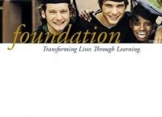
Eligibility:
Provide child care in the following neighborhoods: Brattain, Maple, Fairfield or Malabon
AND

Be CCD licensed or DHS listed (exempt) for 1 year or more
AND

If exempt, be willing to become licensed with the Child Care Division

Join USDA if eligible

You may be qualified to join the 3C’s Network

Benefits for providers include:
Clifford/Harms Environmental Assessment (ECCERS) of your site
Funds for equipment based on Clifford /Harms
Training in the Creative Curriculum©
Support and access to community resources
The chance to network with other local providers
Professional Development support including Oregon Registry Support

Space is limited! For more information please call Terri Hansen at 463-3304 or email at hansent@lanecc.edu

C
C
C
N
United
Way
Family Connections

