Choosing a Framework for your Learning Community Integration
adapted from http://www.mcli.dist.maricopa.edu/ilc/monograph/appendix/app_1.html
What will be the major unifying force of your learning community?
- Parallel concepts
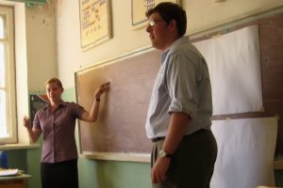
Get together with your fellow faculty and work with your syllabi as they are in stand-alone courses. Are there concepts that you are working with in your class that resonate in your colleague’s class? Is there a major theme in your course that has a corollary in your colleague’s class? Discuss these parallels with your colleague and look into developing an integrated assignment that could help students to see these parallels. Deep learning will occur as students make connections among these concepts.
- Overlapping concepts
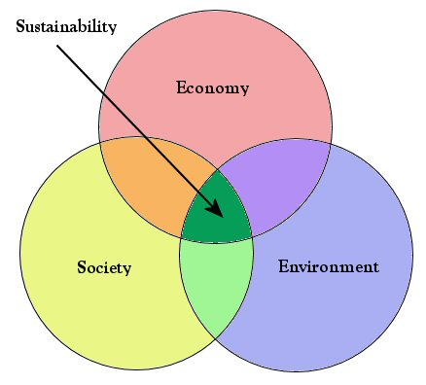
Are there major concepts in your course that are minor concepts in your colleague’s course? Perhaps this is a place for an integrated assignment!
- Content course with skill courses
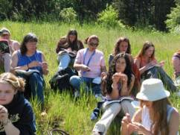
Our First Year Experience (FYE) learning community, Fast Lane to Success, is a great example of this combination of skills with content. In the Writing or Math FYE course, students are learning critical skills and content that provide the foundation for their learning at Lane. In their College Success and Effective Learning classes, they learn the best path to success both socially and academically.
- Common project
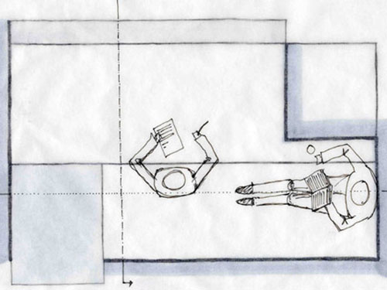
Courses whose content may seem divergent have successfully been developed into successful learning communities through common projects that harness all the learning from both courses—critical thinking, content, creativity and collaboration. Writing classes combined with Biology classes have produced wonderful student reflections and essays on sustainability, the natural world, and the role of science in the environment.
- Common theme
Sustainability * Is All Politics Local? * Is Peace Possible? * Reason and Creativity
Because the goal of learning communities is deep learning about the world students share with us, any number of classes from different disciplines can be unified by thinking of a major question at issue, problem, situation or phenomenon and using coursework to investigate from the particular lens of the disciplines. This kind of learning community can provide students with a wonderful exploration of how knowledge is created in the disciplines, how different lenses on the same question can bring different answers, and the importance of recognizing and respecting different perspectives, knowing that all knowledge is partial.

