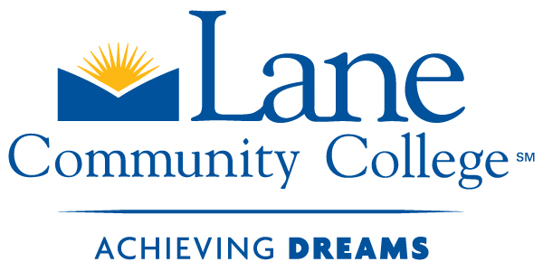
Baking and Pastry Certificate
Application
Fall 2011

**Applications will be accepted starting March 28, 2011 for Fall 2011 Enrollment**
Submit in person to Bldg 19/202 -or- Mail to: 4000 E 30th Ave, Bldg. 19/202, Eugene, OR 97405
IMPORTANT NOTE TO STUDENTS
This Baking and Pastry Certificate program is NOT considered a One-Year Certificate of Completion.
The Certificate is embedded within the 2-Year Culinary Arts and Foodservice Management AAS degree program. All Certificate courses are also available to accepted 2-Year AAS students as program electives or for the Culinary Arts students who are also obtaining the Certificate.
Registration for these courses are on a first-come, first-serve basis. Students are responsible for understanding the advanced and open registration dates and process in order to register for these courses successfully.

To be considered for the Baking & Pastry Certificate Program, you must:
- Have an LCC student L# and an email address.
- Complete the following application. Please answer the questions thoughtfully, using complete sentences. Use a separate sheet of paper for extended answers.
- YOU MUST TURN IN the following documents with your completed application in order to be considered for admissions to the Baking and Pastry Certificate Program:
  - New LCC students, please attach a copy of your placement test scores with the following minimum scores: writing-64, reading-68, and readiness for MTH 025 – taking Math Placement Test Parts A, B, and C – 7 out of 10 in each part.
  - Students with previous college, please attach a copy of your unofficial transcripts.
  - Two (2) reference letters (one from a past or current employer and one personal character reference.) The letter from your employer must be on Business Letterhead and both letters must be signed.
  - Copy of current food handlers card (can be obtained online for $10)
- Timely applications to the program are crucial. The program fills up quickly and is based on first applied and qualified, first admitted. Submit the completed application packet by June 30, 2011. Late applications will be accepted if spaces remain available.
For questions, please contact:
Wendy Milbrat Julie Fether Carolyn Litty Claudia Riumallo
Admin. Support Spec. Special Projects Program Counselor Academic Advisor
541-463-3503 541-463-3518 541-463-5236 541-463-5378
milbratw@lanecc.edu fetherj@lanecc.edu littyc@lanecc.edu riumalloc@lanecc.edu
Bldg 19/202 Bldg 19/204 Bldg 12/202 Bldg 12/202
Please note: Incomplete applications will not be considered

Baking and Pastry Certificate
Application
Fall 2011
Important Information
Please review the Baking and Pastry Certificate instructions to ensure your application is complete. Please note incomplete applications will not be considered.
-------------- OFFICE USE ONLY --------------
Applicant # _______ Initials _______
Date _______________
Time: _______________

Your Information (Please Print)
Student I.D. L__ __ __ __ __ __ __ __
___________________________________________________________________
Last Name First Name Middle Initial
___________________________________________________________________
Mailing Address, Street
___________________________________________________________________
City State Zip or Postal Code
_______________________________ (____)__________________________
Email Cell / Home / Message Phone (please circle one)

Prior Education: (check one)
_____ NEW COLLEGE STUDENT – Complete college placement tests with the following minimum scores: Writing-64, Reading-68, and readiness for MTH 025 – taking Math Placement Test Parts A, B, and C – 7 out of 10 in each part. (attach copies of test score sheets to application)
_____ STUDENT WITH PRIOR COLLEGE – Attach a copy of your approved unofficial transcript(s). Math must be current within one year or a placement test will need to be taken. Please see Carolyn Litty, Program Counselor, for transcript approval. Bldg. 12/202, Mon-Thurs 7:00 am- 1:00 pm -- (541)463-5236 –littyc@lanecc.edu

Following submission, you may be called for an interview.

Please answer the questions thoughtfully, using complete sentences. Use a separate sheet of paper for extended answers.  Your Printed Name:______________________________ | Office Use Only
1. What motivated you to apply to the Baking & Pastry program? | 1 2 3 4 5
2. What experience have you had so far in the culinary or baking industry? | 1 2 3 4 5
3. Where do you see yourself professionally in five years with your degree? | 1 2 3 4 5
4. Describe any of your circumstances that would impact your ability to participate fully and/or complete the program. | 1 2 3 4 5
5. Have you taken any college courses that apply to the Culinary Arts and Food Service Management degree? (circle one) Yes No  If yes, attach an unofficial transcript. | 1 2 3 4 5
6. Explain what components of culinary arts inspire you to pursue this field of study? | 1 2 3 4 5
 | Total

