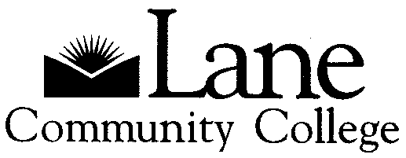

Lane Community College Archives
4000 East 30th Avenue
Eugene, Oregon 97405
Phone: 541-463-5466
Fax: 541-463-3996
E-mail: archives@lanecc.edu

Guide to Community College Moment
2001 – 2010

A-060

Collection processed by: Elizabeth Uhlig, 2010

Repository Name: Lane Community College Archives
4000 East 30th Avenue
Eugene, OR 97405
Phone: 541-463-5466
Fax: 541-463-3996
E-mail: archives@lanecc.edu

Collection Number: A-060

Creator: Language, Literature and Communication Department

Title: Community College Moment

Dates: 2001 - 2010

Quantity: 2 document boxes (1 cubic foot)

Summary: This collection consists of the Community College Moment, an academic journal published by the faculty of LCC.

Location of Collection: Lane Community College Archives, Center Building

Administrative History: The Community College Moment is a ”faculty-led journal that offers a forum for high quality progressive works that reflect a new vision of scholarship at the intersection of academic, activist and community interests.” The journal has a Review Panel which reads submissions and provides feedback to authors. The editors are faculty members from the Language, Literature and Communication Department. The journal was first published in 2001 and is issued in the Spring term of each academic year.

Content Description:
This collection consists of printed copies of the Community College Moment which contains articles interviews, photographs, artwork, poetry, and other original work that reflect the interests of community college teachers and scholars. Recent issues have focused on themes such as diversity, sustainability, technology and society, democracy, and new directions.

Arrangement:
The Community College Moment journals are arranged chronologically.

Subjects:
Lane Community College (Eugene, Or.)
Colleges and universities
Lane Community College (Eugene, Or.)—Community College Moment
Lane Community College (Eugene, Or.)—Publications

Alternative Forms Available:
Repository maintains guide to collection on an in-house database. A guide to the collection is also available on the repository’s website and on the Northwest Digital Archives website.

Administrative Information:

Restrictions on Access: The collection is open for research.
Restrictions on Use: There are no restrictions on use.
Preferred Citation: Community College Moment, 2001-2010 (A-060), Lane Community College Archives, Eugene, Oregon
Custodial History: Administrative transfer.
Processing Note: Collection was processed and described in 2010 by Elizabeth Uhlig.

CONTAINER LIST

Box Folder Title
1 1 2001, Spring, Volume 1 – Community College Moment: Exploring this Moment in the Community College: Special Inaugural Issue
2 2002, Winter, Volume 2—The Community College Moment
3 2002, Spring, Volume 3—The Community College Moment
4 2004, Spring, Volume 4—The Community College Moment
5 2005, Spring, Volume 5—The Community College Moment: Diversity
6 2006, Spring, Volume 6—The Community College Moment: Sustainability

2 1 2007, Spring, Volume 7—The Community College Moment: Technology & Society
2 2008, Spring, Volume 8—The Community College Moment: Democracy
3 2009, Spring, Volume 9—The Community College Moment: New Directions
4 2010, Spring, Volume 10—The Community College Moment: Ten Years

